Unixplus
Statement of work for
SIEM Deployment
and
Security Operations

Table of Contents
1. SIEM Implementation 2
1.1. Introduction 2
1.2. Key Services in Scope: 2
1.3. Assumptions : 2
1.4. Service Coverage: 2
1.5. Deployment Process for the Central Infrastructure ( in Kenya) 3
1.6. Deployment Process at Opco Locations 4
1.7. Tech Mahindra Implementation Responsibilities: 5
1.8. Customer Responsibilities: 5
2. SIEM Sizing Considerations: 6
3. Bill of Quantity (BoQ) : 6
4. Architecture Diagram: 8
5. Overall High Level SIEM roll out Plan 9
6. Security Operations Center 9
6.1. Introduction 9
6.2. Key objectives of the Security Operations Center 10
6.3. Key activities of the Security Operations Center 11
6.3.1. Monitoring 11
6.3.2. Security Management 12
6.3.3. Indicative List of Reports 13
6.4. Suggested SLA and KPI Matrix 15
7. Resource Summary 17

- SIEM Implementation
  - Introduction
TECH MAHINDRA will provide “SIEM Implementation Services”, which means performing those functions associated with the provision of Security Information and Event Management (SIEM) to MAHINDRA COMVIVA in accordance with security policies established by MAHINDRA COMVIVA, as per the scope of this Statement of Work.
  - Key Services in Scope:
- Tech Mahindra will implement the SIEM solution (ArcSight Express appliance in Mahindra Comviva Data Centre at customer location in Kenya),
- Monitoring of Airtel Money application stack covering 17 African countries,( See Section 5 ) based on using HP ArcSight.
- Management of security devices which are deployed to protect the Airtel Money application stack
  - Assumptions :
- Any changes to “Statement of Work” ( SOW ) to be addressed through Change Request (CR)
- All assumptions mentioned in this SOW will be verified during assessment.
- SIEM solution will be deployed based on centralized architecture.
- Mahindra Comviva Data Center facilities will be adequate to support any current or future requirements
- Mahindra Comviva will maintain valid current support, security content updates and maintenance contracts for all required system components of assets under scope of SIEM implementation.
- Flex connectors development is not required.for the ArcSight Express integration activity.
  - Service Coverage:
SIEM Implementation Services will be delivered onsite at customer location in Kenya and off-site from the Security Operations Center at Tech Mahindra location in India as described below.

During the implementation phase Tech Mahindra will provide the Services under this Statement of Work (SOW) during normal business hours, 09:00 a.m. to 5:00 p.m. Monday through Friday in the time zone of the respective countries, except national holidays, unless otherwise specified.
  - Deployment Process for the Central Infrastructure ( in Kenya)
# | Phase | Activities
1 | Project Origination/Initiation | Project Plan Finalization
1 | Project Origination/Initiation | Sharing Requirement gathering document for Assets under integration scope to Client
1 | Project Origination/Initiation | Client to share the filled Asset database sheet to Tech. M Team
1 | Project Origination/Initiation | Log baseline document sharing with Customer by Tech. M for the devices mentioned in RFP
1 | Project Origination/Initiation | Send meeting invites for Project Kick off meeting and Project Awareness Presentation
1 | Project Origination/Initiation | Approval of data center requirements by Data Center Team
1 | Project Origination/Initiation | Project Initiation meeting (Kick-off Meeting)
1 | Project Origination/Initiation | Meeting with Network team, Windows, Unix, Security team to discuss the log baseline and Use Case document
1 | Project Origination/Initiation | Identifying contact points of asset owner from Client Project Manager
1 | Project Origination/Initiation | Milestone Signoff
3 | Setup New ArcSight Express | Obtaining license and necessary installers from Client's ArcSight portal
3 | Setup New ArcSight Express | Rack Mounting the ArcSight Express Server
3 | Setup New ArcSight Express | Connecting the ArcSight Express servers to Network
3 | Setup New ArcSight Express | Install and Configure ArcSight Express server (one at a time)
3 | Setup New ArcSight Express | Installing ArcSight Console on Client's machine
3 | Setup New ArcSight Express | Assigning destinations for smart connectors
3 | Setup New ArcSight Express | Testing post installation test scenario for all the ArcSight Appliance
3 | Setup New ArcSight Express | Milestone Signoff
4 | Agent Servers configuration | Rack mounting and installing all the agent servers
4 | Agent Servers configuration | Connecting all the Agent servers to Network
4 | Agent Servers configuration | Providing RDP/Remote access from the users machine
4 | Agent Servers configuration | Milestone Signoff
5 | Device Configuration and integration | Log baseline distribution to IT teams (Log baseline document explains the configuration steps to be followed on the end devices in order to enable auditing and/or log sending to the ArcSight components. This should be followed by the device owner prior to integrating the same with ArcSight.
5 | Device Configuration and integration | Change Request creation and submission
5 | Device Configuration and integration | Configuration at the respective device end by the device owners
5 | Device Configuration and integration | Corresponding port openings, if required
5 | Device Configuration and integration | Installation of respective smart connectors on the agent servers
5 | Device Configuration and integration | Integrating the devices using smart connectors
5 | Device Configuration and integration | Verifying whether the logs are being received at ArcSight
5 | Device Configuration and integration | Milestone Signoff
6 | Rules/ Dashboard/ Reports Creation | Discussion on Use case with security team
6 | Rules/ Dashboard/ Reports Creation | Finalizing use cases, alerts, reports, dashboards. Identifying notification contacts.
6 | Rules/ Dashboard/ Reports Creation | Implementing use case in ArcSight solution
6 | Rules/ Dashboard/ Reports Creation | Testing use cases in ArcSight ESM
6 | Rules/ Dashboard/ Reports Creation | Share the Sample use case and reports from ArcSight to Client
6 | Rules/ Dashboard/ Reports Creation | Use case signoff from security team
6 | Rules/ Dashboard/ Reports Creation | Milestone Signoff
7 | Documentation and Training | Preparing and submitting installation document and SOP
7 | Documentation and Training | Preparing and submitting ArcSight admin documents
7 | Documentation and Training | ArcSight Express and basic Logger Training
7 | Documentation and Training | Development of SOC operational standards based on best practices and frameworks like ITIL
7 | Documentation and Training | Milestone Signoff
8 | SI completion and move to operations phase | Transition into operations phase.  Staff the security operations center to run on 24 X 7 X 365 basis

  - Deployment Process at Opco Locations
- Setup the ArcSight connector hardware and software
- Send the log baseline information to IT teams and obtain their concurrence
- Commence logging on all devices
- Setup fliters to capture necessary events
- Setup the VPN connectivity from Opco location to central site
- Start log shipping to central location
- Generation of events
- Correlation and incident management
- Reports and dashboards
- Periodic vulnerability assessment.

  - Tech Mahindra Implementation Responsibilities:
- Assess Mahindra Comviva requirements and environment on business and technology objectives and develop the required security strategy for SIEM implementation.
- Recommend if any changes needed for SIEM Implementation for optimal performance.
- Provide details on Network Access requirements for SIEM Implementation services.
- Install the physical SIEM appliances and begin integration of log source devices and applications.
- Testing and verification.
  - Customer Responsibilities:
- To provide Tech M with contact information for Comviva Security SPOC ( Single Point of Contact)
- To provide the Network/Physical access as needed from Tech M for SIEM Implementation Services.

- SIEM Sizing Considerations:
# | Vendor | Product Type | Product OS version | Qty per site | Single Instance EPS | Total EPS
1 | Cisco ASA 5520 (2) | Firewall | ASA 5520 | 2 | 300 | 600
2 | Cisco Catalyst 2960 (2) | Switch | 2960 G | 2 | 50 | 100
4 | IBM HS-22 Blades (12) | Linux Servers | HS -22 | 12 | 50 | 600
8 | Windows Servers |  |  | 1 | 50 | 50
9 | Database Servers |  | Oracle 11g | 3 | 10 | 30
10 | IDS/IPS / VPN |  | N/A | 2 | 150 | 300
7 | Radware App Director 2008 | Load Balancers |  | 2 | 5 | 10
8 | Hardware Security Module | HSM |  | 2 | 100 | 200
9 | Application Logs |  |  | 1 | 110 | 110
27 |  |  |  |  | Total EPS per Site | 2000
 |  |  |  |  | For 17 Sites: | 34000

- Bill of Quantity (BoQ) :
Sl.No | Description | P/N | Quantity
1 | HP ArcSight Lgr 30GB/d 200Dev SW E-LTU HP ArcSight Logger collecting up to 30GB/day from a maximum of 200 Devices. total searchable space 800 GB per Instance Software E-LTU | TH478AAE | 17
2 | HP-Premium Support - 5 years |  | 85
3 | HP ArcSight Lg 30GB/d 200Dev HA SW E-LTU HP ArcSight Logger HA collecting up to 30GB/day from a maximum of 200 Devices. total searchable space 800 GB per Instance High Availability Software E-LTU | TH486AAE | 17
4 | HP-Premium Support - 5 years |  | 85
5 | HP ArcSight ESM Suite 100 Gb/d SW E-LTU HP ArcSight Enterprise Security Manager Suite 100 Gb per day Software E-LTU | TF712AAE | 1
6 | HP-Premium Support - 5 years |  | 5
7 | HP ArcSight LgrCIP PCI 1 Imp SW E-LTU HP ArcSight Logger Compliance Insight Package for PCI First Implementation Reported Against Software E-LTU | TH245AAE | 1
8 | HP-Premium Support - 5 years |  | 5
9 | HP ArcSight FlexConnect Kit SW E-LTU HP ArcSight FlexConnector Kit Software E-LTU | TH330AAE | 1
10 | HP-Premium Support - 5 years |  | 5

Hardware Requirements:
- Logger VM Resource Requirements:
VMWare Virtual Appliance, 8 core, 12 GB RAM, 100 GB for OS and 800 GB for Data.

- ESM SW Resource Requirements:
RHEL 6.2 64-bit, 40 Core, 64 GB RAM, (3*500GB SATA RAID5) inc HBA Card

- Connector SW Resource Requirements:
RHEL 6.2 64-bit, 8-Core, 12 GB RAM, 1.5 TB (usable) RAID-5

- SAN Hardware Requirements:
10TB usable 15k RPM, RAID10 (SAS), 35K IOPS
- Architecture Diagram:
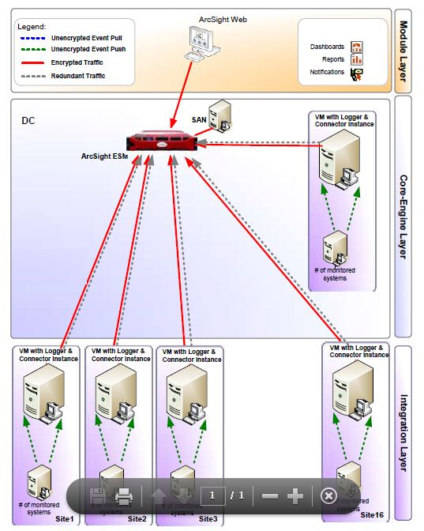
At each site, Software Logger and Connector instances will be configured under same Virtual Server. Connector instance will integrate with data sources to pull/push the logs. Connector will forward the logs to both loggers for local storage and will provide retention based on available storage. Logger1 will forward logs to centralized ESM for correlation. When Logger1 will not be available, Logger2 will start forwarding logs to ESM. Due to bandwidth constraints, it require manual forwarding settings at Logger2. Using local logging through Logger provide log availability within the country and will be complied to country specific acts. Administrator will their own privileges can centrally or remotely monitor the security activities and getting notified with configured mode.

- Overall High Level SIEM roll out Plan
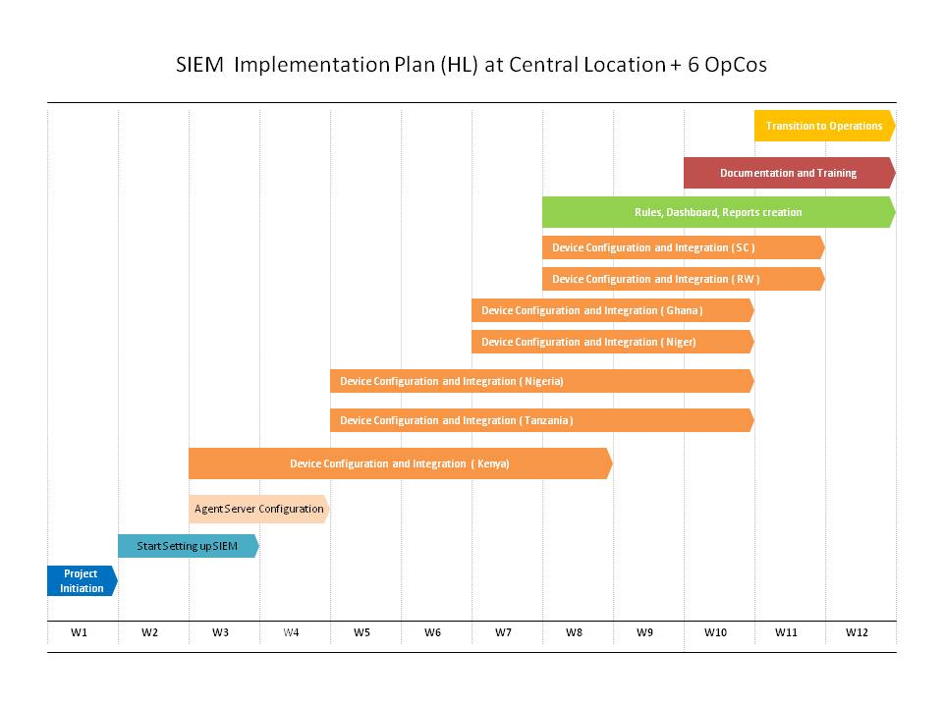
- Security Operations Center

  - Introduction
This document describes the functions and activities performed by the Security Operations Center (SOC) for Airtel Money. SOC is part of the Infrastructure Managed Services provided by Tech Mahindra and focused on protection of information from internal and external threats.
Around-the-clock vigil maintained by SOC is expected to bring in Risk intelligence by continuous monitoring which will enable Airtel to maintain an alert security posture and adopt a proactive approach to security management, so that its application estate is adequately protected from risk exposure.
From the standpoint of incident management, the SOC will play a pivotal role by providing early warning and alerts to respective infrastructure and application teams on malicious traffic and suspicious activities so that they are able to respond effectively and prevent security breaches. In the event of policy violation or security breach the SOC will facilitate incident response and mitigation process in order to maintain continuity of operations and mission critical services like Airtel Money
The heart of the Security operations center is the Security Information and Event Management solution HP ArcSight which aggregates logs from IT Infrastructure devices and correlates events to identify events which could pose Security Risk to Airtel Money.
  - Key objectives of the Security Operations Center
- Around-the-clock monitoring of Security events and provide in-depth information security expertise.
- Vigil over the IT infrastructure using ArcSight SIEM tool to identify suspicious or abusive events.
- Alert the IT team to suspicious or abusive events qualified as security incidents
- Respond to security incidents with the respective infrastructure team to ensure satisfactory mitigation.
- Periodic vulnerability scanning of servers and application to ensure that systems remain adequately patched and protected from web based threats
- Provide assurance to all stakeholders and Sr. Management on the security posture through reports.
  - Key activities of the Security Operations Center
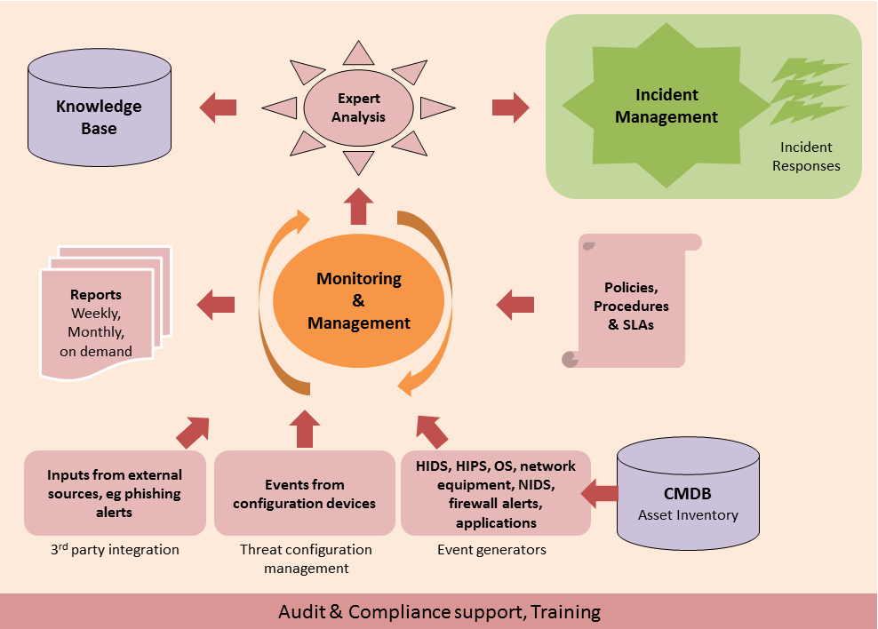
    - Monitoring
- Maintain a 24x 7 vigil for events from all Network, Systems, and Application and Security devices in scope of the operations
- Provide information in the form of alerts to infrastructure and application teams in the event of suspicious activity and/or traffic.
- Analysis of alerts to ensure removal of false positives. Raise incident ticket in the Service Desk Tool to ensure relevant teams are enabled to respond to security incidents promptly.
- Provide daily incident summary with detailed analysis for each ticket which is raised in the service desk tool.
- Identify mitigation measures for incidents and work with respective infrastructure teams to ensure satisfactory mitigation.
- Integration of devices with ArcSight Express SIEM as and when required (Configuration, administration and fine tuning of ArcSight Express SIEM)
- Development of customized and advances correlation rules to monitor attacks and suspicious activities
- Ongoing optimization of correlation rules to minimize instances of false positives
- Provide assurance to all stakeholders and Sr. Management on the security posture through regular reporting and dashboards. Reports will be provided on daily weekly and monthly basis. Indicative list of reports which need to be generated are provided in section
- Perform vulnerability scanning as per schedule basis for in scope critical systems and devices in scope using Nessus. Eliminate false positives and send reports to relevant IT teams for patching vulnerabilities
- Generation of vulnerability advisories on a periodic basis to provide early warning information and adopt a preventive and proactive stance to security. Work with relevant IT teams to patch vulnerabilities wherever possible.
In the current setup qualification of reported vulnerabilities cannot be done as sand box environment for testing is not available
- The functions of the SOC will be documented in functional manual. The functional manual will cover the following details
    - Mission Statement
    - Objectives of the Security operations center
    - Organization Structure with roles and responsibilities
    - Shift Roster
    - Key Processes
    - Interfaces with other operational functions
    - SLA and support details with vendors and their contact details
    - List of Reports with frequency
    - SLA and KPI Matrix
    - Security Management

- Management of security devices like Firewalls, IPS, AV etc. and configuration of the same in line with defined policies.
- Hardening of Airtel Money infrastructure by developing and implementing a secure configuration for all devices and systems in scope. The secure configuration should be developed based on industry best practices, benchmarks and vendor recommendations for secure configurations
- Once secure configuration baseline is approved, a gap analysis needs to conducted against the same and baselining plan needs to be developed in conjunction with IT teams. Wherever hardening cannot be enforced due to design or functional limitations, security team will work with relevant teams for seeking risk acceptance.
- Tech M will define an operational policy document which will be aligned with the BISP. This policy will be guiding document to ensure secure delivery of services to for Airtel Money.
- In order to impart a structured approach to technical vulnerability management tech M will document and implement the patch management process. Tech M security analyst will work with respective IT teams in order to ensure patch deployment for all systems in scope as and when necessary.
- Wherever patches cannot be deployed due to design or functional limitations exceptions will be sought from Airtel Money IT and security teams depending on extent of risk exposure.
- Patch status will be reported by security team on a periodic basis.

    - Indicative List of Reports
Daily Reports
Report Title | Description
Machines with old Antivirus Definitions | This report shows the older DAT versions in the Airtel Money machines.
Machines with Virus Infections | This report shows the summary of viruses found in the Airtel Money machines
DB Login Failures | This report shows the summary of DB login failures found in the Airtel Money Infrastructure.

DB Access from Non App Servers | This report shows summary of direct access to the DB servers
Internal IPS Alerts | This report shows the summary of the IPS Internal Alerts for permitted traffic since IPS is configured in detect mode
Top 10 Firewall Blocked Machines (Internal) | This report shows the summary of Top 10 Firewall Blocked Machines in Airtel Money Network
Top 10 Firewall Blocked Ports (Internal) | This report shows the summary of Top 10 Firewall Blocked Ports in Airtel Money Network
*nix failed logins | This report shows the summary of *Nix failed logins which include failures of privilege user logins
*nix SU Command Usage | This report shows the summary of *Nix SU command usage
Failed Login after Office hours | This report shows the summary of failed login after office hours
Windows Account Lockout | This report shows the summary of Windows account lockout
Windows admin failed logins | This report shows the summary of the Windows admin failed logins
Windows group member added-removed | This report provides a group member server which is added is removed from AIRTEL MONEY Network
Windows Group Created-Deleted | This report shows summary of Windows Group Created & Deleted
Windows RDP connections | This report shows the summary of the Windows RDP connections
Windows server shutdown and restart | This report shows the summary of the Windows server shutdown and restart.
Windows service failures | This report shows the summary of the Windows service failures
Windows user account created-deleted | This report shows the summary of the windows user account created and deleted
VPN login failures | This report shows the summary of VPN login failures
Weekly Reports
Report Title | Description
Antivirus update trend | This report shows the updated DAT versions trend in Airtel Money machines.
Virus Infection Trend | This report shows the trend of number of viruses found in Airtel Money machines

Region wise Virus Infection report | This report shows the location wise number of viruses found in Airtel Money machines
Source of Virus | This report shows the source of virus from where it has entered to Airtel Money machines/network.
AV service stopped – Servers | This report shows the AV service stopped on Servers in Airtel Money network.
DB Failed login trend | This report shows the Trend of DB login failures found in Airtel Money Infrastructure.
DB Access from Non Application Servers | This report shows trends of direct access to the DB servers bypassing application servers.
Internal IPS alerts | This report shows the Trend of the IPS Internal Alerts for permitted traffic since IPS is configured in detect mode
Firewall Denied Connections (Internal IPs) | This report shows the Trend of Denied connection from Internal IPs in Airtel Money Network
Top 5 Denied Ports (Internal) | This report shows the Trend of Top 5 Denied Ports (Internal) in Airtel Money Network
*nix SU Command Usage | This report shows the Trend of *Nix failed logins which include failures of privilege user logins
*nix Failed Logins | This report shows the Trend of *Nix SU command usage
Windows Account Lockout | This report shows the Trend of Windows account lockout observed.
Windows user account lockout by Region | This report shows the Trend of Windows user account lockout region wise.
Windows admin failed logins | This report shows the Trends of the Windows admin accounts login failures.
Windows RDP connections | This report shows the number of Windows RDP connections made without using the Jump server
VPN login failures | This report shows the Trend of VPN login failures

  - Suggested SLA and KPI Matrix
Service Description | Event Management
Objective | Used to calculate actionable events into incidents
Explanation | Correlation of Network & infrastructure management tool events with service management tool incidents
Calculation method | Number of actionable events not converted to incidents / Total  no of actionable events converted to incidents.
Frequency | Monthly
Target | < 15%
Criticality | Critical

Service Description | Security Operations Center
Objective | SOC will be Available exclusive of planned downtime
Explanation | Availability of SOC infrastructure and connectivity to access Airtel Money environment in each OpCo. Report from monitoring tools.
Calculation method | 100% minus Unavailability %
Frequency | Continuously
Target | 99.5%
Criticality | Critical

Service Description | Event Management
Objective | Used to calculate actionable events into incidents
Explanation | Correlation of Network & infrastructure management tool events with service management tool incidents
Calculation method | Number of actionable events not converted to incidents / Total  no of actionable events converted to incidents.
Frequency | Monthly
Target | < 15%
Criticality | Critical

Service Description | Incident Management ( Sev 1 . Sev 2 and Sev 3 )
Objectiv | Measurement to calculate number of severity incidents resolved within the Service Levels
Explanation | Report from the Service Desk tool
Calculation method | Number of incidents resolved within the Service Level / Total number of incidents
Frequency | Continuously
Target | Severity 1 | 99%
Target | Severity 2 | 97%
Target | Severity 3 | 95%
Criticality | Severity 1 | Mission Critical
Criticality | Severity 2 | Critical
Criticality | Severity 3 | Non -Critical

Priority Code | Description | Target Response Time | Target Resolution Time
P 1 | Critical/ Major Incident | 30 Minutes | 4 Hour
P 2 | High | 2 Hours | 6 Hours
P 3 | Average | 6 Hours | 16 Hours
P 4 | Low | 12 Hours | 24 Hours

- Resource Summary
# | Activity | Number of resources | Time Frame | Role
1 | Setup of Central Infrastructure and optimization | 02 | 12 weeks | 1. ArcSight Product Specialists  SOC Analyst
2 | Integration of ArcSight with Opco location infrastructure | 02 per location | 6 weeks | Network and Systems Analysts  SOC Analysts

