NTP Configuration using IPv6 address in RHEL6

Step:-1 Verify Packages of NTP

#yum install ntp*
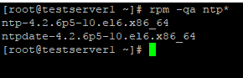
Step:-2 Add NTP server IP on bottom in respective servers
#cat /etc/ntp/conf
# cat /etc/ntp.conf
disable monitor
restrict default kod nomodify notrap nopeer noquery
restrict -6 default kod nomodify notrap nopeer noquery
restrict 127.0.0.1
restrict -6 ::1
server -6 2a00:5aXX:XXXX::cc8:XXXX <- IPv6 address of the NTP server
driftfile /var/lib/ntp/drift
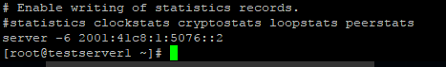
Step:-3 Then restart ntpd daemon to reload new configuration.
#service ntpd start
Step:-4 Also check that NTPD listens on IPv6 port 123
# netstat -an | grep 123
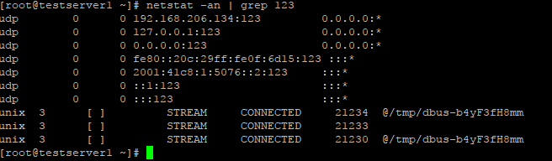

Done

