IPv6 Addressing configuration

- Editing line to /etc/sysconfig/network
Networking_IPV6=yes
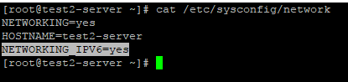
- Assign GW and IP address on single interface as manually.
#Editing line on below.
IPV6ADDR=2001:41c8:1:5076::3/64 --(IPv6 addressing and netmask)
IPV6_DEFAULTGW=2001:41c8:1:5076::1 --(IPv6 GW)
IPV6INIT=yes
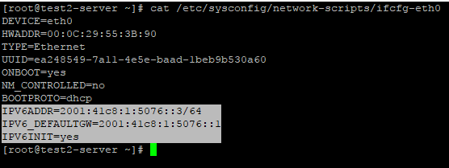
- services should be stop NetworkManager before start network service

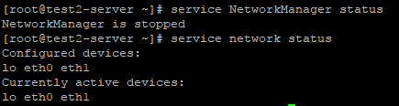
- Identify IPv6 address on system.
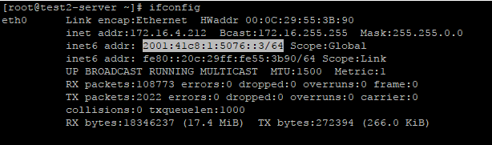

- check IPv6 is working or not by using pinging
#ping6 2001:41c8:1:5076::3
