FTP Configuration using IPv6 in RHEL6, RHEL7

[Server side]
Step:-1 Installed vsftp* Packages.
#yum install vsftp*
Step:-2 Change parameter in /etc/sysctl.conf.
Edit /etc/sysctl.conf and add and make it active:
# vim /etc/sysctl.conf
net.ipv6.bindv6only = 1
# sysctl -p
#sysctl –w
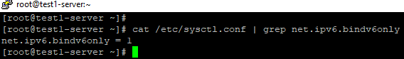

Step:-3 Just edit the vsftpd configuration and change the listen directives in /etc/vsftpd/vsftpd.conf:
comment listen # listen
uncomment listen_ipv6 : set values to listen_ipv6
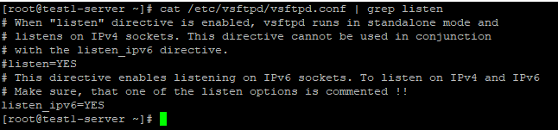
Step:-4 Just start service on vsftpd. Verify
#service vsftpd start
# netstat -tanp | grep vsftp (check port is enabled or not.

[client side]

Step:-5 login prompt using ftp
Make sure ftp packages should be installed.
#yum installed ftp*
#ftp ipv6adress or #ftp username@ ipv6adress.
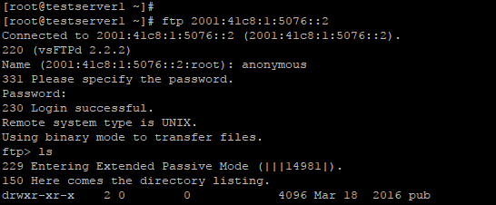

Done

