NeSSUS Installation

PREREQUSITES

This section includes information related to the requirements necessary to install Nessus and Nessus Agents.
- Hardware Requirments

Scenario | Minimum Recommended Hardware
Nessus scanning up to 50,000 hosts | CPU: 2 dual-core 2 GHz CPU  Memory: 4 GB RAM (8 GB RAM recommended)  Disk space: 30 GB
Nessus scanning more than 50,000 hosts | CPU: 4 dual-core 2 GHz CPU  Memory: 8 GB RAM (16 GB RAM recommended)  Disk space: 30 GB (Additional space may be needed for reporting)
Nessus Manager with up to 10,000 agents | CPU: 4 dual-core, 2GHz CPU  Memory: 16 GB RAM  Disk space: 30 GB (Additional space may be needed for reporting)
Nessus Manager with up to 30,000 agents | CPU: 4 dual-core, 2GHz CPU  Memory: 64 GB RAM  Disk space: 30 GB (Additional space may be needed for reporting)

- Software Requirments

- Nessus Manager and Nessus Professional
Operating System | Supported Versions
Linux | Debian 7, 8, and 9 / Kali Linux 1, 2017.1, and Rolling - i386  Debian 7, 8, and 9 / Kali Linux 1, 2017.1, and Rolling - AMD64  Red Hat ES 6 / CentOS 6 / Oracle Linux 6 (including Unbreakable Enterprise Kernel) - i386  Red Hat ES 6 / CentOS 6 / Oracle Linux 6 (including Unbreakable Enterprise Kernel) - x86_64  Red Hat ES 7 / CentOS 7 / Oracle Linux 7 (including Unbreakable Enterprise Kernel) - x86_64  FreeBSD 10 and 11 - AMD64  Fedora 24 and 25 - x86_64  SUSE 11 and 12 Enterprise - i586  SUSE 11 and 12 Enterprise - x86_64  Ubuntu 12.04, 12.10, 13.04, 13.10, 14.04, and 16.04 - i386  Ubuntu 12.04, 12.10, 13.04, 13.10, 14.04, and 16.04 - AMD64
Windows | Windows 7, 8, and 10 - i386  Windows Server 2008, Server 2008 R2*, Server 2012, Server 2012 R2, Server 2016, 7, 8, and 10 - x86-64

- Nessus Agents
Operating System | Supported Versions
Linux | Debian 7, 8, and 9- i386  Debian 7, 8, and 9 - AMD64  Red Hat ES 6 / CentOS 6 / Oracle Linux 6 (including Unbreakable Enterprise Kernel) - i386  Red Hat ES 6 / CentOS 6 / Oracle Linux 6 (including Unbreakable Enterprise Kernel) - x86_64  Red Hat ES 7 / CentOS 7 / Oracle Linux 7 - x86_64  Fedora 24 and 25 - x86_64  Ubuntu 12.04, 12.10, 13.04, 13.10, 14.04, and 16.04 - i386  Ubuntu 12.04, 12.10, 13.04, 13.10, 14.04, and 16.04 - AMD64
Windows | Windows 7, 8, and 10 - i386  Windows Server 2008, Server 2008 R2*, Server 2012, Server 2012 R2, Server 2016, 7, 8, and 10 - x86-64
Mac OS X | Mac OS X 10.8, 10.9, 10.10, 10.11, 10.12, and 10.13 - x86-64
- Browsers
Nessus supports the following browsers:
- Google Chrome (50+)
- Apple Safari (10+)
- Mozilla Firefox (50+)
- Internet Explorer (11+)

- DOWNLOADS
Below is the link to download the agent as per the platform .
https://www.tenable.com/downloads/nessus-agents

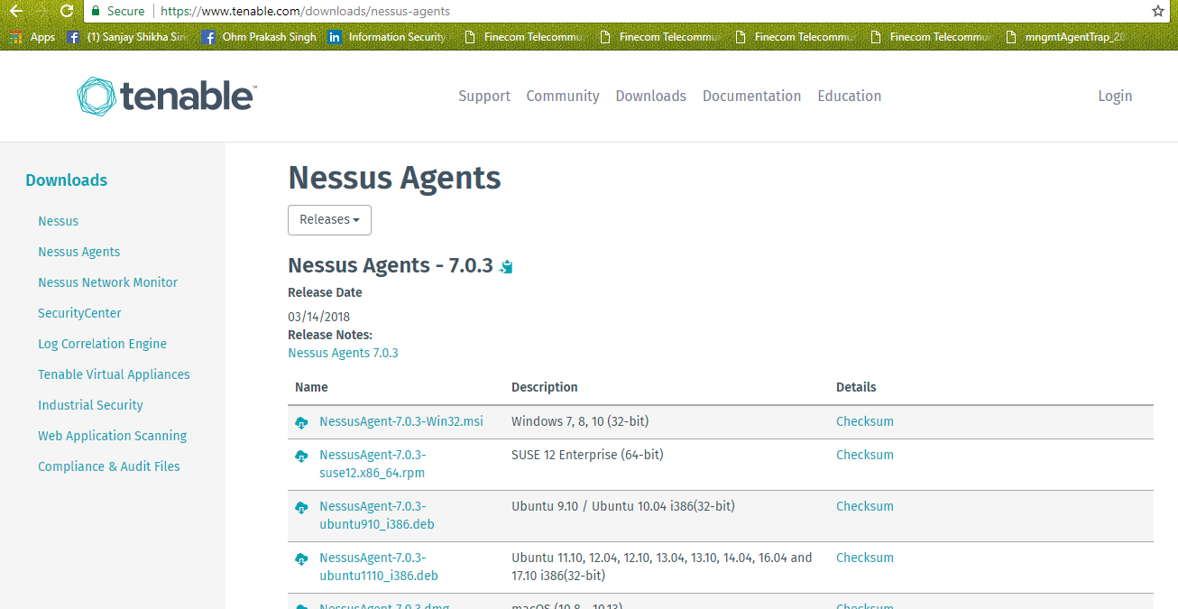

- Registration
https://www.tenable.com/products/nessus-home
above is the Registration link to Register the machine .’
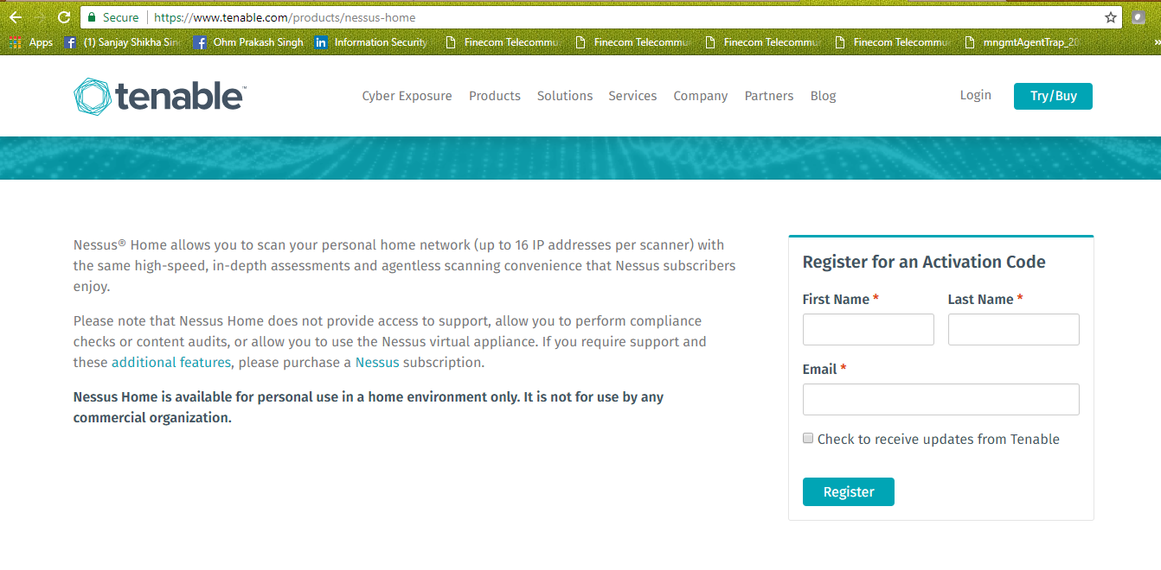

- Installation
Install the Nessus Agent and follow the instructions to install it .
