OPENVAS Operational Procedure

- Below is the home screen of open vas .
- Start Scan on the middle right hand side will be used to scan the host.
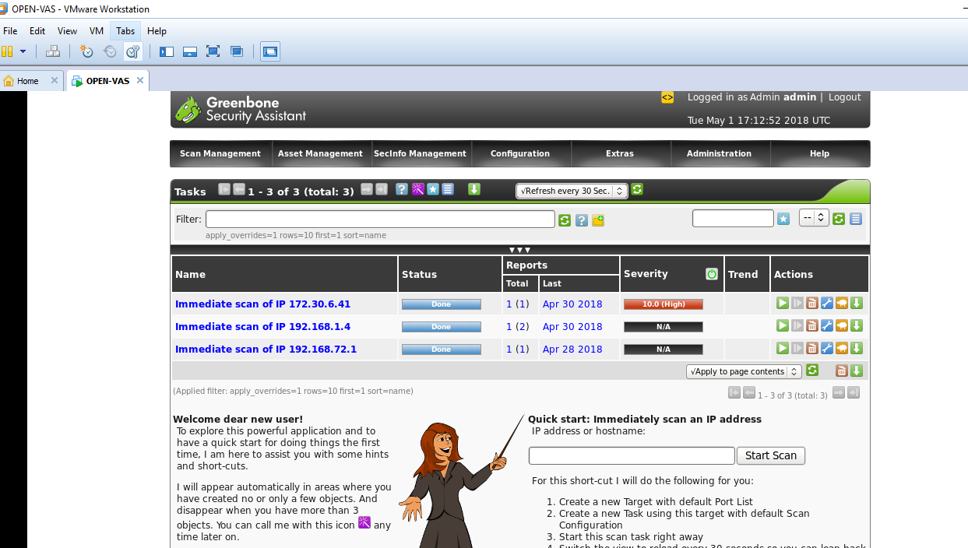

- The highlighted box shows the status of the nodes tested .

- Click on report button as shown in the artefacts .
- It will show the reports after the PT.
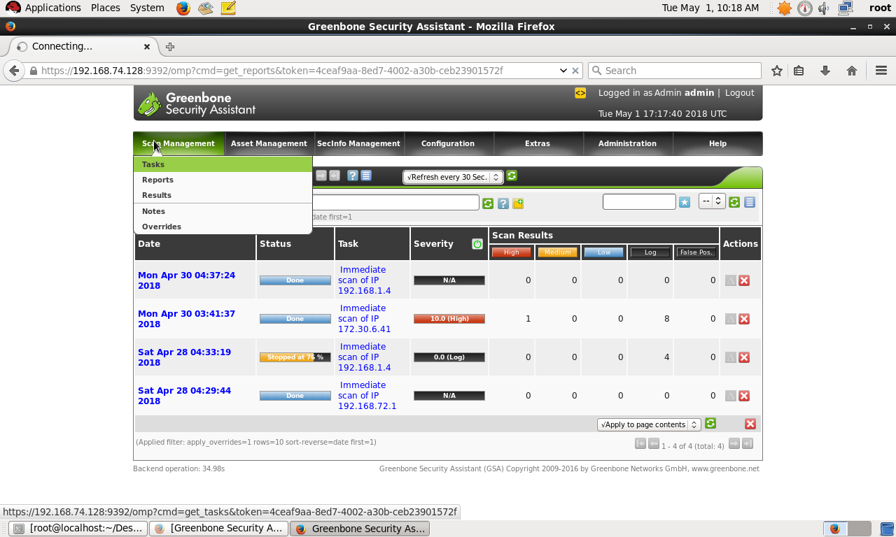

- Below artefacts show the vernabilities found in the system .
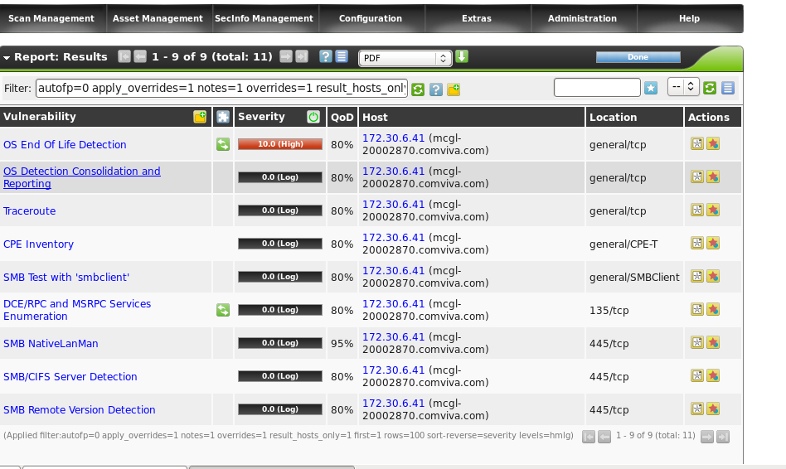

- Click on the download button and choose the appropiate export type ,eg :- PDF,excel.
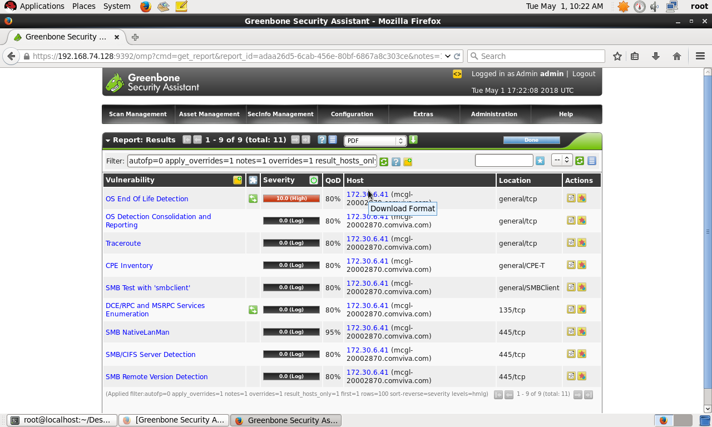

- Below is the Sample report generated from Open Vas

