OPENVAS INSTALLATION

Prerequisite
- Virtual Machine
- Minimum requirements: 2 CPU Cores, 2 GByte RAM
- Type: Linux
- Version: Other Linux (64bit)
- Memory: 2048M
- Hard disk: 9G
- CPUs: 2
- Internet Connectivity should be available in the VM machine .

Installation
- Download the Open Vas Packages and install it in the VM machine as per below command.

- Follow the instruction as shown in below artefacts.

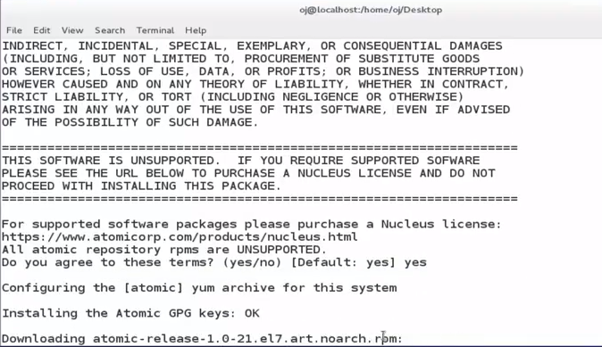

- Run the Below command to install the openvas packages .
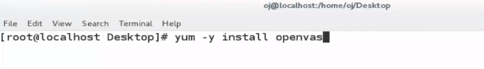
- Below artefacts shows the installation .
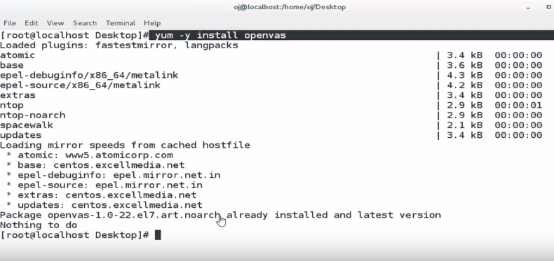

- Run the below command to setup the openvas software .

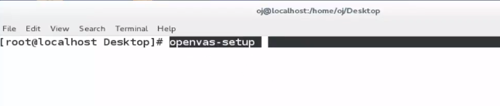
- Give the admin username & password and follow the instruction to complete the setup as below artefacts .
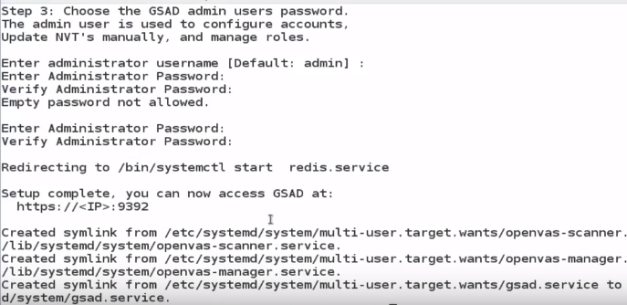

- After completing the openvas setup open the webpage as shown in below artefacts .

