Nessus Manual Guide

OPERATIONAL PROCEDURE

- Below is the Home page of Nessus .
- Use Login Details that was created at the time of registration .
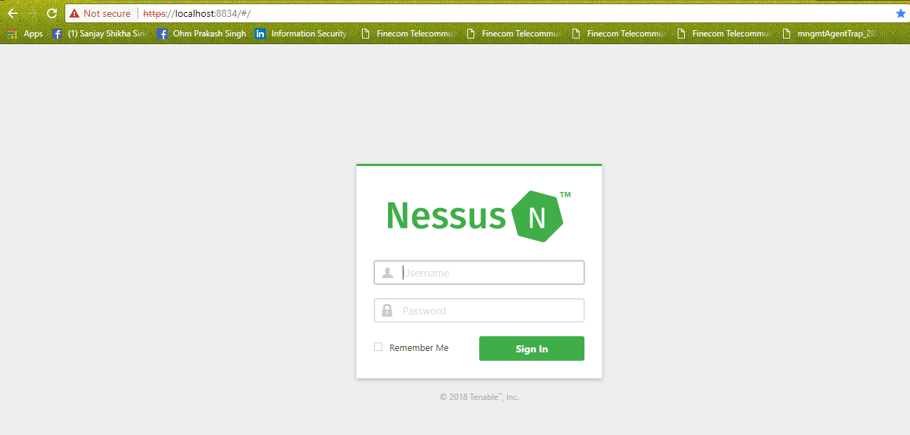
- After the successful login below screen will be shown.
- To start scan click on new scan on the upper right side blue button
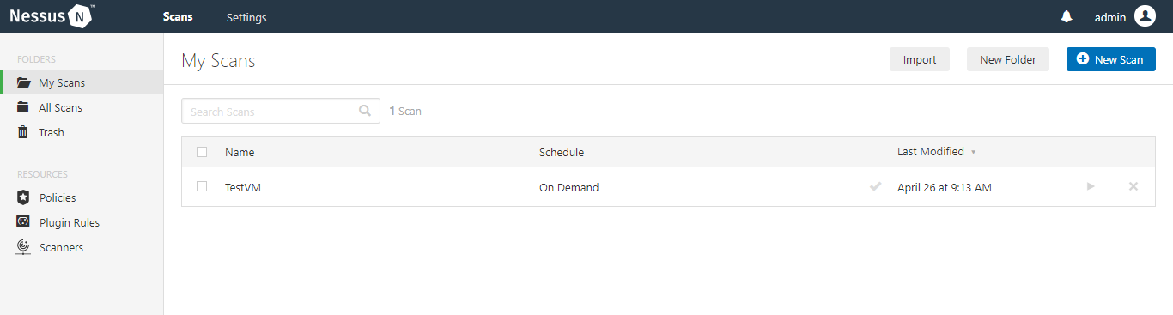

- Choose the Basic Network Scan .
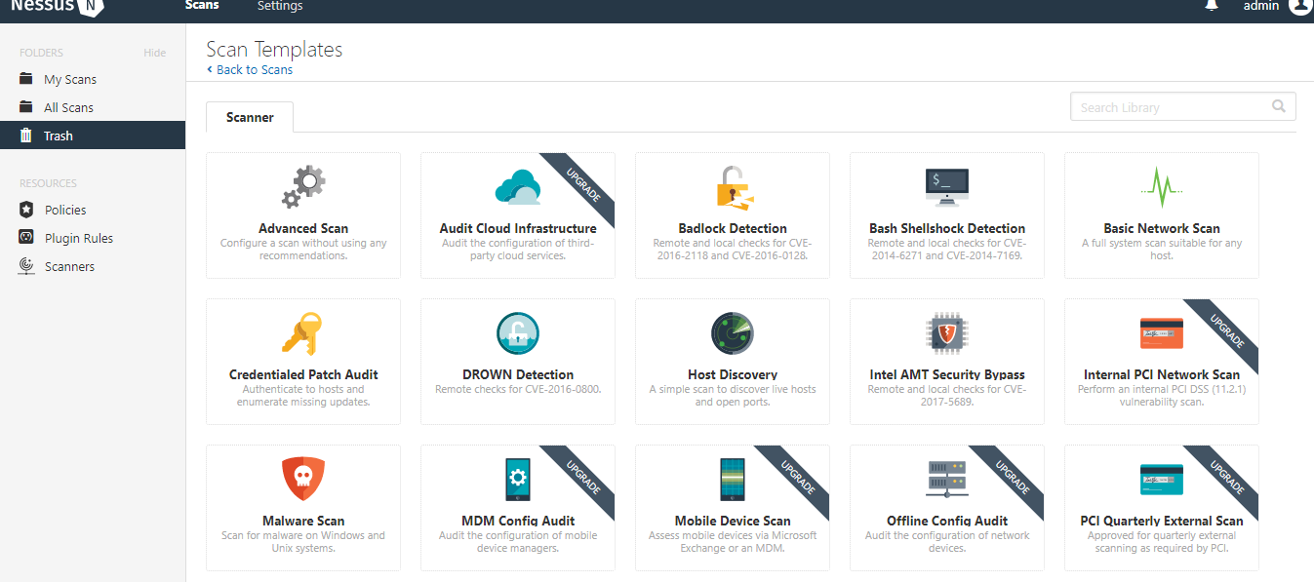
- Fill the target details that are going to be scan for Penetration testing
- Name, description, Target IP’s.
- Select the Schedule if the target host will be scan at any given point of time
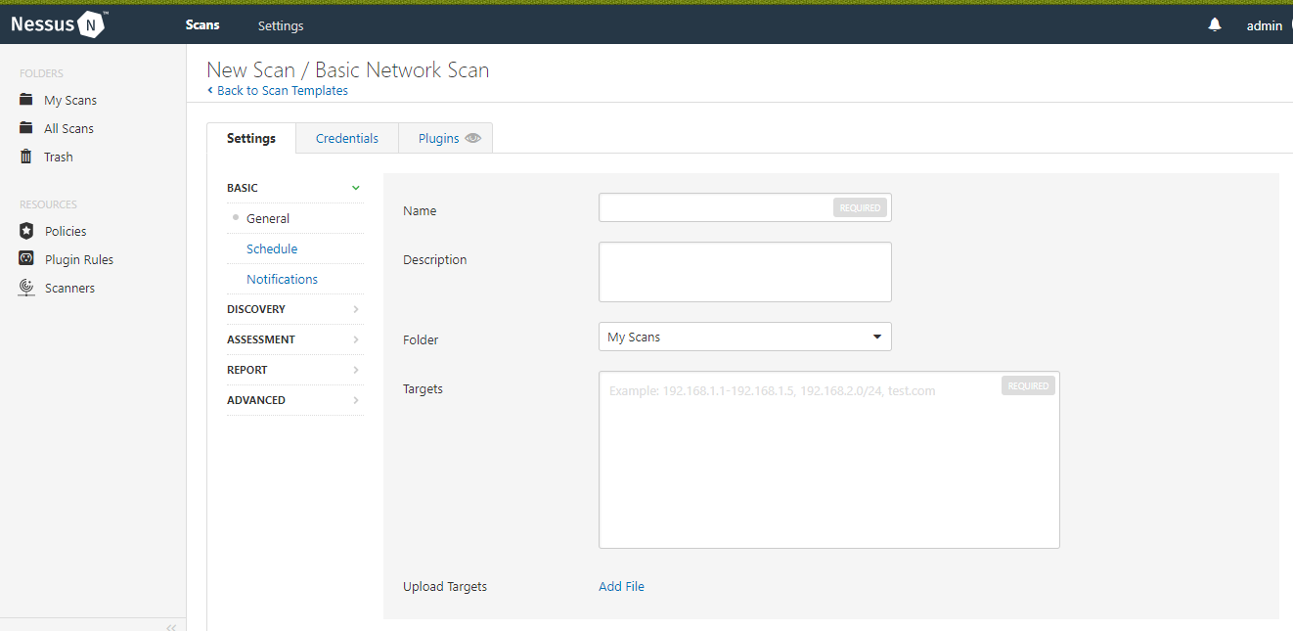

- Select the type of scan , ideally the scan should be for all ports.
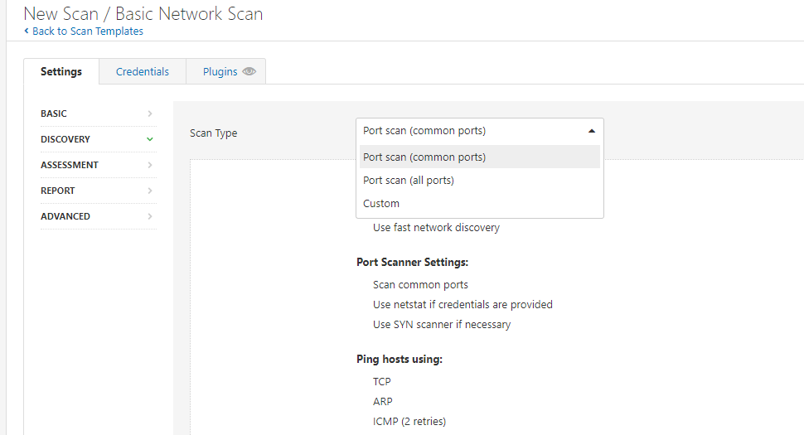

- Below is the showcase of how to configure the Manager to scan the target
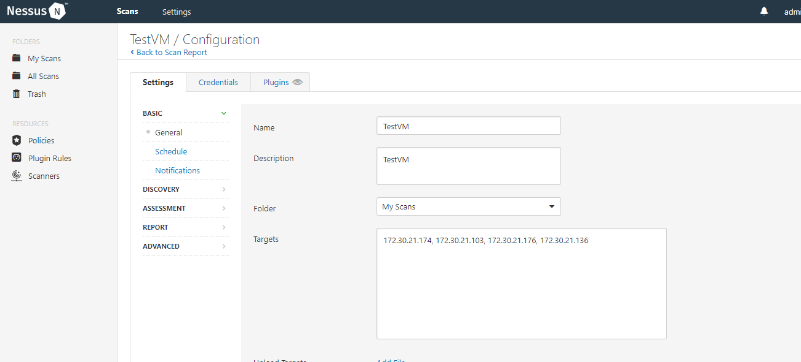

- Go to the All scan, All the configured targeted node will be visible ,choose any of the node and click on start button to start the PT .
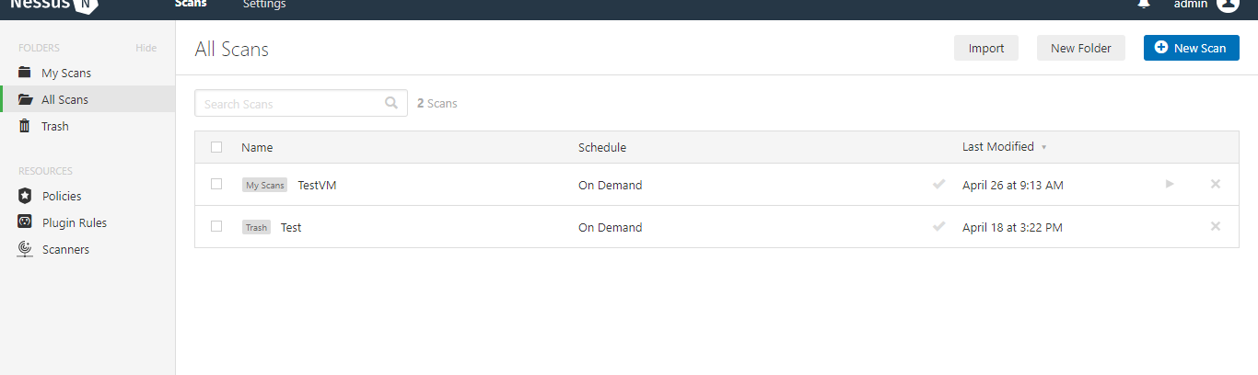
- When the PT is in process it will act like below artefact.
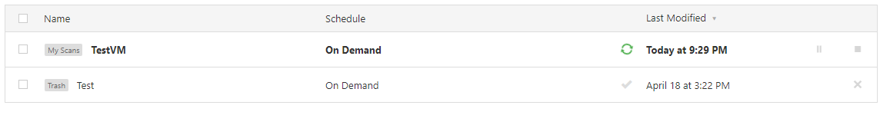
- Once the PT is completed the double click on targeted node to see the PT report .
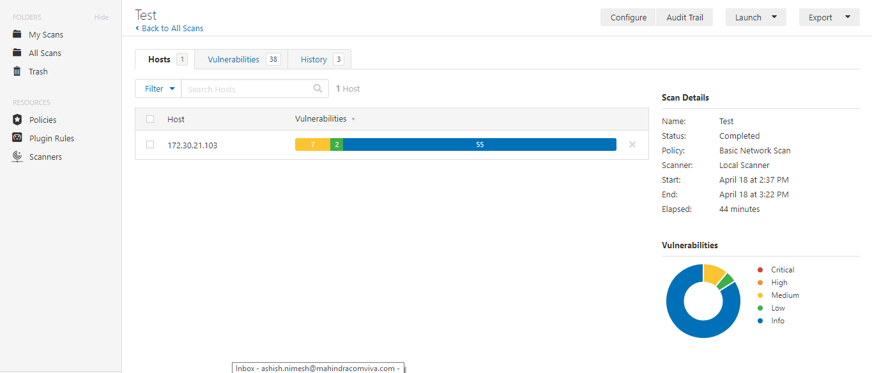

- This artifacts show the Actual VA results o the targeted host.
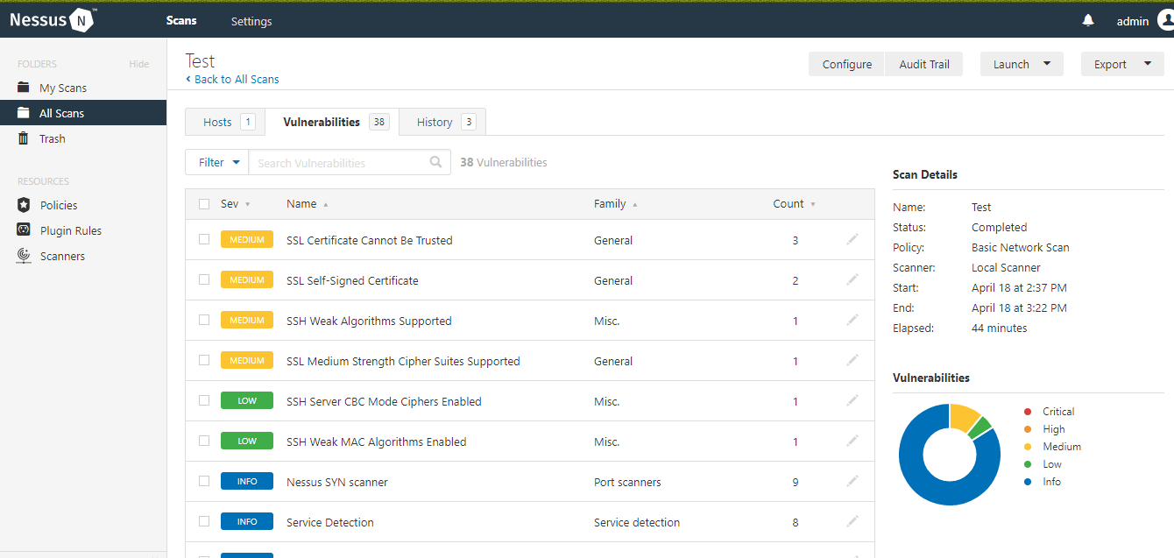

- To know about the Complete Vernabilities click on any vernable point .
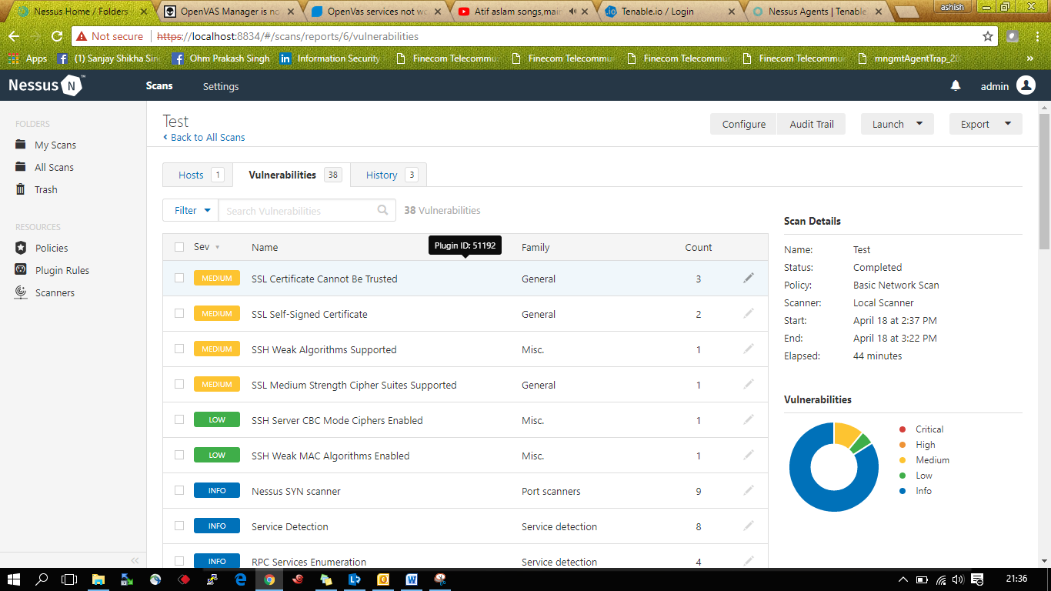

- This artefact shows all the information regarding the Vernability found in the targeted host.
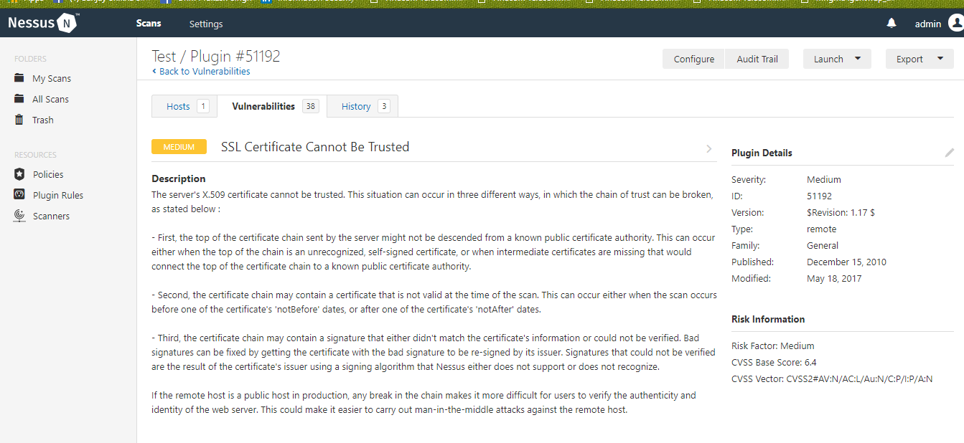
- To export the complete report click on the export button on the upper right side .
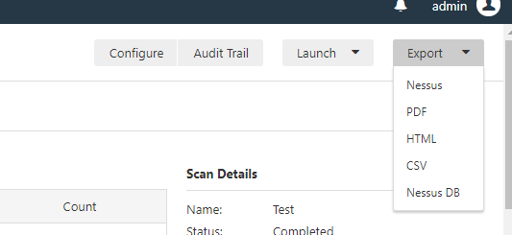

- Below is the sample attached file .

