Security Solution for the Bharti VAS Project

1. Executive Summary 3
Superior Solutions 3
World-class Services 3
Why Choose HP? 4
2. Proposed Solution 5
2.1. Security Solution 6
2.1.1. Security and Network Transformation 6
2.1.2. Countries in Africa covered under the RFP 8
2.1.2.1. Countries Classification 8
2.1.3. Solution Assumptions and Limitations 10
2.1.4. Reference Architecture 12
2.1.5. Design Principles 13
2.1.5.1. Solution Classification as per Deployment Architecture 13
2.1.5.2. Site Classification 14
2.1.5.3. Volumetric Numbers for the Solution Sizing 14
2.1.5.3.1. Port Counts Considered 14
2.1.6. Dependencies for the Security and Network 15
2.1.7. Technical Design 16
2.1.7.1. GNOC cum PDC at Kenya – Proposed Architecture 17
2.1.7.2. Primary Data Center – Proposed Architecture 20
2.1.7.1. Child Site Without Internet – Proposed Architecture 23
2.1.7.2. Child Site With Internet – Proposed Architecture 25

Executive Summary
HP seeks to combine best-in-class security solutions with strong consulting and support to help Airtel achieve success in the marketplace. To sustain this success, HP will provide Comviva with recommendations on security product options and best practices for secure systems-level management. By implementing superior products, leading-edge management technologies, and world-class services from HP, Airtel can achieve agility and growth while maintaining the appropriate levels of data and network security.

Superior Solutions
The quality and diversity of security products selected and services assure of enduring choice and dependability. HP offers security solutions in the following areas.
- Planning and governance solutions—HP security governance services can help Airtel define the business processes and organizational structures necessary to create an effective and sustainable information security program. This solution area includes development of security strategy, policies, organization structure, awareness and training programs, compliance programs, systems of metrics, and planning. In addition, it provides services that support the ongoing maintenance and measurement of a security program including risk and vulnerability assessments as well as specialized assessments focused on particular technologies
- Trustworthy infrastructure—Resources in an IT environment are defined by the characteristics of the service they provide, including how strongly the business applications are protected.
- Security management solutions—With Proposed security management solutions, Comviva can address security events throughout the entire lifecycle, from detection through correction. The HP Security Incident Management Program can help Airtel deal with information security incidents more proactively, efficiently and cost effectively.
- Identity and access management—HP identity and access management solutions address how identities of users of IT resources will be created, evolved, utilized and retired to allocate IT resources to achieve business goals.

World-class Services
HP has a world-class support, consulting and integration organization that offers Comviva a single source for IT services, encompassing both HP and third-party products and technologies. HP Services is staffed by senior practitioners with proven expertise in designing, implementing and supporting customized, end-to-end solutions. Because HP consultants invest time to fully understand Airtel’s unique business requirements, their efforts yield consistently effective results—with reduced risk—in the shortest possible timeframe.
HP end-to-end security solutions are mapped to the security lifecycle model: strategy and policy planning and enforcement; security awareness training; trustworthy infrastructure design, integration, implementation, and testing; web and business-enabling applications deployment and management; multi-vendor product support; and business continuity and disaster recovery planning. Regardless of where Airtel is in the security lifecycle, HP can offer the appropriate solution.

Why Choose HP?
Why should Airtel choose Hewlett-Packard for its security needs? There are several good reasons. First, HP has broad technical expertise to meet a range of enterprise security needs. HP experts have provided ethical hacking, vulnerability analysis and secure design services. They have designed, implemented and supported large-scale solutions involving individual productivity devices, data centers and wired and wireless networks.
Second, with its breadth of experience, HP has encountered—and resolved—almost every conceivable security scenario. We have witnessed firsthand the costs of business-debilitating network attacks and abuses and understand legal liability and the damage that regulatory non-compliance can do to a company’s reputation. We have a proven record of helping enterprises with both broad security needs and local concerns.
Next, HP is committed to delivering standards-based and cost-effective design, implementation and support services to Comviva. Our strong partnerships and “one-stop shop” capabilities mean that HP consultants can offer a wide range of services as well as hardware and software solutions that lower the total cost of ownership (TCO). And HP trusted solutions for multi-vendor, multi-layered environments allow Airtel’s security environment to adapt to growing needs.
Finally, as a corporation, HP has invested strongly in security. HP has committed significant financial and people resources to a number of areas, including secure products and solutions, security services, security standards and flexible architectures. Hundreds of customers worldwide have deployed and depend on our robust solutions to protect their information assets. HP Labs brings deep technical expertise and inventiveness to address today’s problems and tomorrow’s opportunities.
By selecting HP, Comviva will be teaming with an experienced partner and a recognized industry leader. Our collaborative approach means that we will help you at every stage, from identifying the right solution to managing it on a day-to-day basis.

Proposed Solution
HP Security solution is part of overall Comviva’s VAS Service management framework and consists of Transformation, Operations Management Service & will enable Comviva to meet its business objectives of providing comprehensive solution to Airtel-Zain.

Solution elements providing Transformation and Security Solution for VAS Infrastructure based on HP and Industry leading Security Products

Hewlett-Packard thoroughly understands the operational complexities and the business outcomes that HP solution need to achieve. We created the above solution considering a partnership with Comviva & integrated all the elements required to support ultimate objective of VAS Infrastructure Security.
In the following section we briefly describe our proposal with more specific details

Security Solution

Security and Network Transformation

Protecting the VAS Node infrastructure from the forces that seek to infiltrate is one of the most difficult jobs. The threats to the average system are countless; the budget to address them is limited.
HP understands the importance of this requirement & proposes the following Architecture to effectively manage security requirements of Comviva.

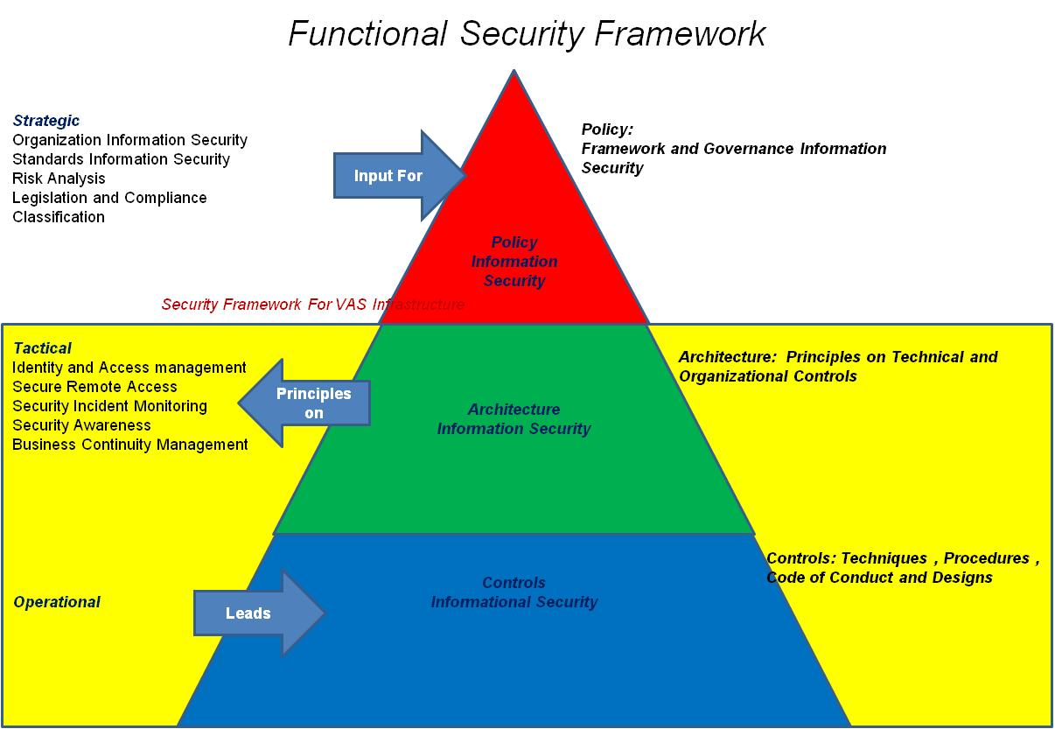

Above figure provides the Security pyramid Framework that provides comprehensive protection to the VAS information assets.

The Policy Framework and Governance on Information security to be provided by the Airtel’s Group Security office and HP to provide the lower layer of the Security pyramid for the VAS Infrastructure with Point Solutions
To meet the functional Architecture, following high level line items proposed by us will enable long term BISSP compliance and shall go a step further in terms of re assessing the network strength. The Security systems proposed are constantly vigilant and adaptive to changes in internal and external environment of Bharti ZAIN’s VAS.

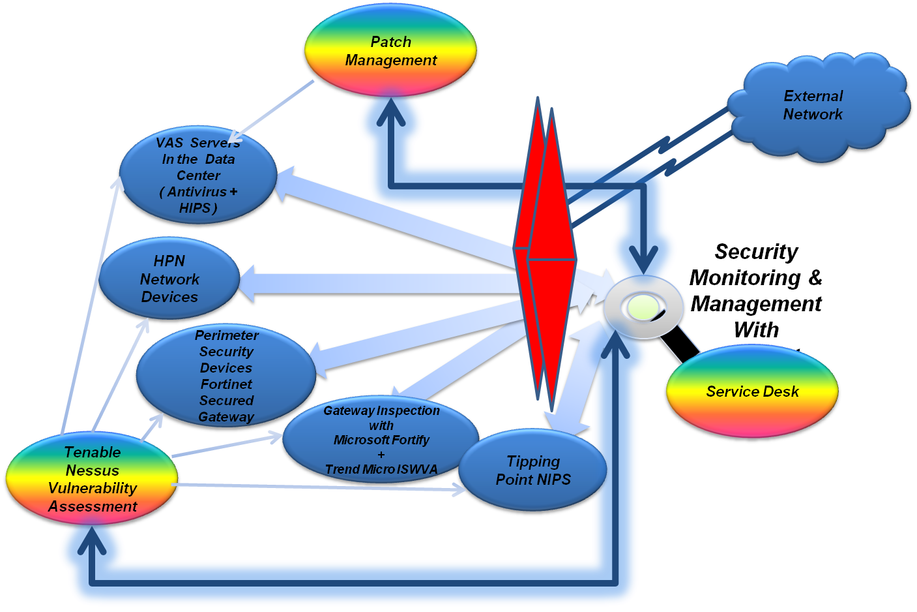

Above figure show the Security posture of the proposed VAS Security Infrastructure point solutions to the external as well as internal threats. All the Individual components interact in the overall Security framework

Countries in Africa covered under the RFP

Sno | Countries | Type | Abv
1 | NIGERIA | A | NG
2 | CONGO BRAZZAVILLE | B | CG
3 | DEMOCRATIC REPUBLIC OF CONGO | B | CD
4 | GABON | B | GA
5 | KENYA | B | KE
6 | TANZANIA, UNITED REPUBLIC OF | B | TZ
7 | ZAMBIA | B | ZM
8 | BURKINA FASO | C | BF
9 | CHAD | C | TD
10 | GHANA | C | GH
11 | MADAGASCAR | C | MG
12 | MALAWI | C | MW
13 | NIGER | C | NE
14 | SEYCHELLES | C | SC
15 | SIERRA LEONE | C | SL
16 | UGANDA | C | UG

Countries Classification

Countries are classified in to the following categories:
Type A: Very Large Operations
Type B: Large Operations (Rev greater than 200 Mn USD)
Type C: Small Operations (Rev less than 200 Mn USD)

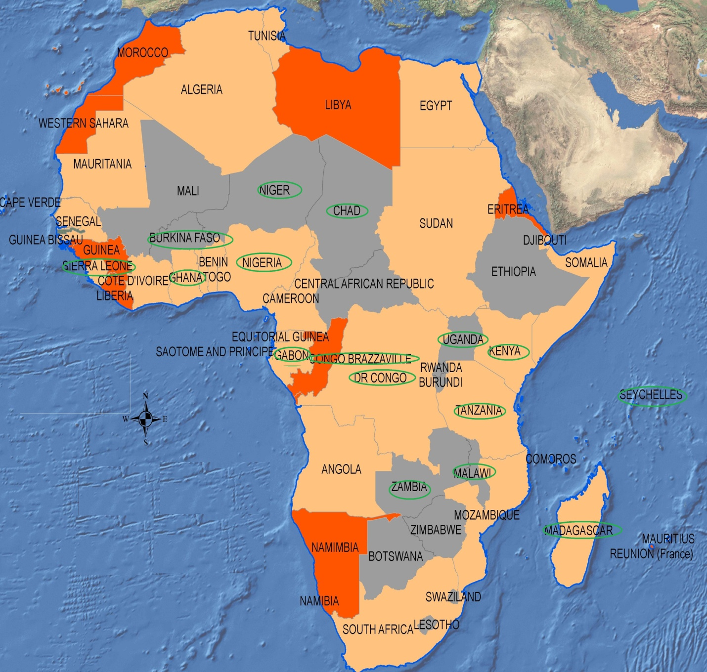
Note: Map is only used for representing the countries covered in the project scope, it doesn’t indicate HP’s understanding of political situation of Africa as a continent.

Solution Assumptions and Limitations

- The solution assumes the following:
  - That Internet connectivity would be made available at the sites.
  - NTP feed would be made available at each PDC
  - Any sort of connectivity to proposed VAS infrastructure would be through a copper ( RJ-45) interface
  - Two layers of firewall architecture is being proposed at sites where there is internet connectivity (GNOC and Primary locations per country), and if there are any child locations with internet.
  - Single layer of firewall is being proposed at sites where there is only WAN connectivity ( child locations within the same country ).
  - VPN would terminate on the internet firewall being proposed for all the sites with internet connectivity
  - A dedicated set of IPS appliance is proposed at the GNOC cum PDC location at Kenya and 5 other major locations, rest all the Primary as well as Child locations are proposed with firewalls with IPS capability.
  - A dedicated set of Gateway AV appliance is proposed at the GNOC cum PDC location at Kenya and 5 other major locations, rest all the Primary as well as Child locations are proposed with firewalls with IPS capability.
  - OAM users are approximately 50 users who would be working on different PDCs over WAN and on IPSEC tunnel over internet.
  - Field support engineers are the engineers who visit the site and work as required. In GNOC, these users would sit in the NOC User zone, in all other DCs with management zone they would sit in the management zone in a different network and in DCs without management zone, they would sit in VAS DMZ zone in a different network as the number of such users is very less of the order of 2-3 users and so we haven’t factored for a separate zone.
  - Internet bandwidth is assumed as follows for equipments sizing:
    - GNOC and major Primary Data centers – upto 4 Mbps
    - Rest of the Primary Data Centers – up to 4 Mbps
    - Child Data Centers – up to 4 Mbps
  - WAN bandwidth is assumed as follows for equipments sizing :
    - GNOC and major Primary Data centers – up to 8 Mbps
    - Rest of the Primary Data Centers – up to 8 Mbps
    - Child Data Centers – up to 4 Mbps
Note: The above bandwidth assumptions doesn’t mean that the solution would seize to work if bandwidth augmentation happens at internet or WAN, however, it may show some performance related issues depending on the utilization.
  - Adequate bandwidth would be provided for GNOC tools to communicate with the local agents and components at each DC.
  - WAN Switches are available at each location with appropriate ports available to uplink the Intranet firewall.
  - Any communication between the VAS and IT or VAS and N/W would happen through the core switches proposed in the architecture at sites with Internet and at sites without internet, this communication would happen over the WAN switches assumed to be available at site.
  - Switches for each zone are kept to be physically separate as per the recommended security practices
  - All the proposed switches are of NON-Blocking architecture and the L3 switches proposed are capable only of static routing and RIP.
- The number of servers at each location and each zone is purely on assumption basis, any change / difference in the assumption v/s actual may imply additional addendum to the bill of materials with respect to the following:
  - Switches
  - Licenses of the likes of the following and not limited to: AV, HIPS, VA, SIEM solution etc.
- The OS, Versions and Application details has not yet been discussed, the actual requirement may imply change of different product from the same OEM or a different product from different OEM
- The number of various types of users has not be finalized and hence difference between assumption and actual may lead to addendum to the bill of material with respect to the following, not limited to:
  - VPN and firewall sizing and licenses
  - AAA sizing and licenses
  - SIEM solution etc.
- The solution doesn’t include pushing AV/HIPS agents of updates to the Remote Access users
- The solution has SIEM as OPTIONAL as discussed.
- WAN and Internet bandwidth per site is requested which is a required parameter to consider in order to size the equipments.
- Equipment type being considered in solution is all AC.
- Our understanding is that earthling, rack space, switch port for the management server connectivity would be provided to us, and kindly confirm the same.
- Under the current understanding, HP will hand over the material to Comviva in Singapore and end Site delivery would be responsibility of Comviva.
- Back up is not considered as part of the solution at all, in both active and passive component respect.

Reference Architecture

Note: This is the reference architecture only. This has been used to design the solution and while doing that we have also incorporated security best practices.

Design Principles

To meet the phased approach, we propose to do the following:
- Classify the Solutions as per Deployment Architecture
- Classify the Sites
- Volumetric Considerations

Solution Classification as per Deployment Architecture

Components | Architecture
Access Management Solution
Firewall + VPN | Per Country
UTM – Firewall+VPN+IPS+AV | All datacenters with Internet except 6 major locations
IPS | At 6 major locations
AAA Software | Per Country
Authentication Manager for 2F Tokens | Per Country
LDAP for User Database | Per Country
Gateway Proxy and AV
Proxy | Per Country
Gateway AV | At 6 major locations
Vulnerabilty Assessment Server | Per GNOC
Vulnerabilty Assessment Client | Per Country
Log Collection and Correlation rule | Per GNOC and per Country optional
Antivirus for VAS and supplied servers and Desktops | Per Data Center
Servers for security tools | All locations as per requirement
LAN Switching | Per Data Center
Network racks | Per Data Center

The above table portrays the centralized /Distributed Design approach taken for the deployment plan for the individual solution components in the Overall Security Solution proposed as per the VAS Security Requirement

Site Classification

All the 27 sites are classified into 3 categories
- Class A GNOC Site with all the Tools
- Class B Parent Site in Country with Existing Internet Connectivity
- Class C Child Site within the Country

Classification of the Sites is based on
- Individual Solution requirement
- Geographical boundary as the bifurcation
- Aggregation points within the Country

Volumetric Numbers for the Solution Sizing

Port Counts Considered

- It has been assumed that any PDC would have approximately 100 servers and 20% of those would have 2 NICs being used on an average for bonding/Teaming and the rest would be using the single NIC i.e.
80 Servers X 1 NIC = 80 ports
20 Servers X 2 NICs = 40 ports
Total number of ports required for servers at a Primary DC would be 120 ports + desktops and security servers

- It has been assumed that any child DC would have approximately 50 servers and 20% of those would have 2 NICs being used on an average for bonding/Teaming and the rest would be using the single NIC i.e.
40 Servers X 1 NIC = 40 ports
10 Servers X 2 NICs = 20 ports
Total number of ports required for servers at a Primary DC would be 60 ports + desktops and security servers

Dependencies for the Security and Network

- AS-IS Network Information and Diagram to be shared for the Solution BOM validation
- Sharing of the most current Due Diligence site reports
- Relevant connectivity to the existing LAN Infrastructure to connect to Supplied Tools and backup servers if need be.
- WAN Interconnectivity of all the Child Datacenters within the Parent Data center within the country and between all the Parent Data Centers, to ensure all the sites are accessible through the GNOC
- Required Power, Cooling, Earthing and space for the Security equipments components supplied. Site requirement Details will be shared with Comviva.
- List of the VAS Vendor contact persons for VAS Vendor Co-ordinations
- Comviva to ensure time bound changes on the VAS Server infrastructure and co-ordination with the VAS Vendors. All the changes on the VAS servers would be responsibility of the VAS equipment providers
- Changes in existing security policies on the existing firewalls , Switch or any other device for traffic flow between the sites for the Tools , Security infrastructure shall be facilitated by comviva.
- Hardening of the VAS Servers to be removed for the AV Installation.
- Log retention Policy for the respective countries to be shared by Comviva in advance
- Project Management from customer to facilitate activities where vendor other than HP is involved.
- Mandatory legal and regulatory requirement of the respective country to be shared in Advance by Comviva .
- List of all the servers and the OS running on them.

Technical Design

To enable the functional design parameters, our technical design is based on a combination of following components
Components | Architecture
Access Management Solution
Firewall + VPN | Per Country
UTM – Firewall+VPN+IPS+AV | All datacenters with Internet except 6 major locations
IPS | At 6 major locations
AAA Software | Per Country
Authentication Manager for 2F Tokens | Per Country
LDAP for User Database | Per Country
Gateway Proxy and AV
Proxy | Per Country
Gateway AV | At 6 major locations
Vulnerabilty Assessment Server | Per GNOC
Vulnerabilty Assessment Client | Per Country
Log Collection and Correlation rule | Per GNOC and per Country Optional
Antivirus for VAS and supplied servers and Desktops | Per Data Center
Servers for security tools | All locations as per requirement
LAN Switching | Per Data Center
Network racks | Per Data Center

The details of the Individual components are detailed respectively with the Site wise diagrams in following sections

GNOC cum PDC at Kenya – Proposed Architecture

Explanation:
- GNOC is believed to be at the same site as PDC and hence the above architecture proposed is an integrated GNOC and PDC infrastructure. This location is believed to have both internet and WAN connectivity.
- VAS Production and Backup servers are proposed in PDC VAS SERVER FARM ZONE as shown above.
- VAS DMZ ZONE would contain the web servers and non production servers.
- Gateway AV and Proxy zone.
- MANAGEMENT ZONE is the zone where the following components would sit:
  - AAA and 2F authentication solution
  - LDAP cum NTP
  - VA server
  - AV and HIPS manager Server
  - Firewall Management Server
  - IPS Management Server
  - SIEM analysis and correlation server

- A set of IPS appliance in HA is being proposed at GNOC and the segments of the same would be used to protect the PDC VAS SERVER FARM ZONE, VAS DMZ ZONE and the Management Zone
- Bharti Airtel would give a NTP feed at each of the PDC site, preferably upto stratum 2, to the AD including GNOC which would also act as the NTP server for all other equipments at that particular site and also for all the devices and machines at the child datacenter within that country.
- NOC USERS ZONE would be the zone from where the NOC users would operate.
- The remote users are to connect through the IPSEC VPN terminating at the internet firewall in the VAS infrastructure being proposed as part of the solution.
- Solution is being proposed so that the users from a certain vendor is able to access the resources belonging to that vendor only and not any other vendor resources within the same subnet once connected through the VPN.
- The NOT FACTORED components are the components which we assume are available at the sites and if not, we can readily make those a part of the proposal, so please confirm the same.
- The proposed network architecture in GNOC can provide high scalability in long term. Main Design principles used are listed below, (but are not limited to):
  - Fault resilience
  - Interoperability of technology and product
  - Scalability
  - Security

- The components of the proposed network in GNOC are:
  - Set of Firewalls with IPSEC VPN capability – Internet
  - Set of Firewalls with IPSEC VPN capability - Intranet
  - PDC VAS SERVER FARM ZONE switches
  - MANA]GEMENT ZONE switches
  - VAS DMZ ZONE switches
  - NOC USERS ZONE Switches
  - Core Switches
  - Network Intrusion Prevention System
  - Vulnerability Assessment Server
  - AV and HIPS Server
  - Authentication Manager for 2F authentication and AAA server
  - LDAP cum NTP
  - Proxy
  - Gateway AV
  - SIEM Solution - Optional

Primary Data Center – Proposed Architecture

Explanation:
- PDC is the primary cite at each country. These are the locations with both internet and WAN connectivity.
- VAS Production and Backup servers are proposed in PDC VAS SERVER FARM ZONE as shown above.
- VAS DMZ ZONE would contain the web servers and non production servers.
- Gateway AV and Proxy zone
- MANAGEMENT ZONE is the zone where the following components would sit:
  - AAA and 2F authentication solution
  - LDAP cum NTP
  - VA Scanner
  - AV Server
- The remote users are to connect through the IPSEC VPN terminating at the internet firewall in the VAS infrastructure being proposed as part of the solution.
- Solution is being proposed so that the users from a certain vendor is able to access the resources belonging to that vendor only and not any other vendor resources within the same subnet once connected through the VPN.
- The NOT FACTORED components are the components which we assume are available at the sites and if not, we can readily make those a part of the proposal, so please confirm the same.
- The proposed network architecture in PDC can provide high scalability in long term. Main Design principles used are listed below, (but are not limited to):
  - Fault resilience
  - Interoperability of technology and product
  - Scalability
  - Security

- The components of the proposed network in PDC are:
  - Set of Firewalls with IPSEC VPN – Internet ( at 6 identified PDCs )
OR
  - Set of Firewalls with IPSEC VPN, AV and IPS capabilities– Internet ( at rest of the PDCs )
  - Set of Firewalls with IPSEC VPN and IPS capabilities– Internal
  - IPS appliance ( at 6 identified PDCs )
  - PDC VAS SERVER FARM ZONE switches
  - VAS DMZ ZONE switches
  - MANAGEMENT ZONE switches
  - Core switches
  - Vulnerability Assessment Client
  - AV and HIPS agents
  - Authentication Manager for 2F authentication and AAA server
  - LDAP cum NTP server
  - Proxy
  - Gateway AV
  - SIEM Solution - Optional

Child Site Without Internet – Proposed Architecture

Explanation:
- Child location is a secondary site at country. These are the locations with only WAN connectivity. Internet to them is extended only through the PDC within that country over the WAN link.
- VAS Production and Backup servers are proposed in PDC VAS SERVER FARM ZONE as shown above.
- VAS DMZ ZONE would contain the web servers and non production servers as well as the AV server as we haven’t proposed a MANAGEMENT ZONE AT THE child site. Child site would depend on PDC for the following components:
  - AAA and 2F authentication solution
  - LDAP cum NTP
  - VA Scanner
  - Gateway AV
  - Proxy
- The remote users are to connect through the IPSEC VPN terminating at the internal firewall in the VAS infrastructure at PDC and then they would come through the WAN to access the servers at the child location as there is no internet connectivity at the child locations.
- Solution is being proposed so that the users from a certain vendor is able to access the resources belonging to that vendor only and not any other vendor resources within the same subnet once connected through the VPN.
- The NOT FACTORED components are the components which we assume are available at the sites and if not, we can readily make those a part of the proposal, so please confirm the same.
- The proposed network architecture in PDC can provide high scalability in long term. Main Design principles used are listed below, (but are not limited to):
  - Fault resilience
  - Interoperability of technology and product
  - Scalability
  - Security

- The components of the proposed network in Child DC are:
  - Set of Firewalls with IPSEC VPN and IPS capabilities– Internal
  - PDC VAS SERVER FARM ZONE switches
  - VAS DMZ ZONE switches
  - AV and HIPS agents

Child Site With Internet – Proposed Architecture

Explanation:
- These are child locations with both internet and WAN connectivity.
- VAS Production and Backup servers are proposed in PDC VAS SERVER FARM ZONE as shown above.
- VAS DMZ ZONE would contain the web servers and non production servers including Proxy server as we haven’t proposed a MANAGEMENT ZONE AT THE child site. Child site would depend on PDC for the following components:
  - AAA and 2F authentication solution
  - LDAP cum NTP
  - VA Scanner
- Child location doesn’t need a management zone; it would rely upon the PDC for the same.
- The remote users are to connect through the IPSEC VPN terminating at the internet firewall in the VAS infrastructure.
- Solution is being proposed so that the users from a certain vendor is able to access the resources belonging to that vendor only and not any other vendor resources within the same subnet once connected through the VPN.
- The NOT FACTORED components are the components which we assume are available at the sites and if not, we can readily make those a part of the proposal, so please confirm the same.
- The proposed network architecture can provide high scalability in long term. Main Design principles used are listed below, (but are not limited to):
  - Fault resilience
  - Interoperability of technology and product
  - Scalability
  - Security

- The components of the proposed network are:
  - Set of Firewalls with IPSEC VPN, IPS and gateway AV capabilities– Internet
  - Set of Firewalls with IPSEC VPN– Internal
  - PDC VAS SERVER FARM ZONE switches
  - VAS DMZ ZONE switches
  - Core switches
  - An existing component to also serve as NTP master for the PDC and child location for that country, such as core switches or AD.
  - AV and HIPS agents
  - Proxy

