Procedure to Disable an Unwanted port
- Security Team run a security scan on system and provides a list of open ports on system.
- OS team get a concurrence form Application and DB team for business related ports and rest of the ports needs to be disabled other than OS related ports.
- Below is the procedure followed to disable unwanted services / ports. Here we will take an example of NTP service / port 123 and demonstrate how to disable it:
Procedure to check service status:
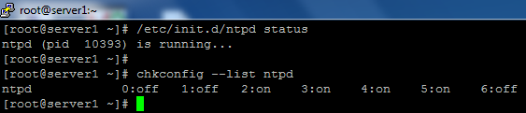

How to verifying which ports been used by NTP service

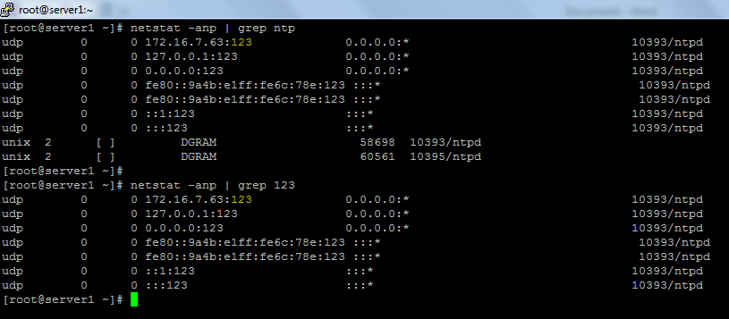

How to stop the services

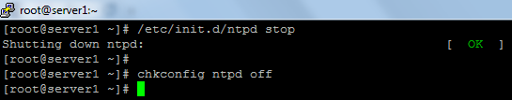

Status of service

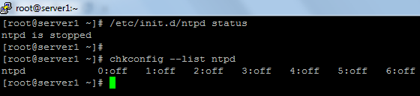

And then check ports are listening status

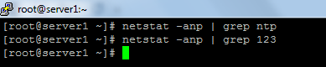

Now in some of the practical cases we found even after disabling service, port may still remain open for existing sessions. Below is the procedure to disable that:
How to check services port
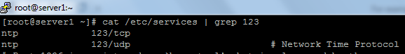
How to change or stop services port in services file:

How to check port status in service file.
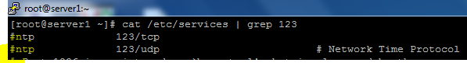
Now we can check port status by netstat –anp | grep ntp or netstat –anp | grep 123 command.
Here is one more procedure to kill active sessions by taking example of http service.
Fist check the services status
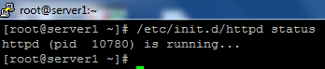
And then check the service process id
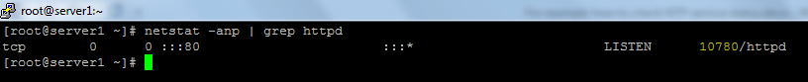
And kill the process
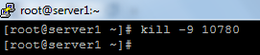
Check service status
